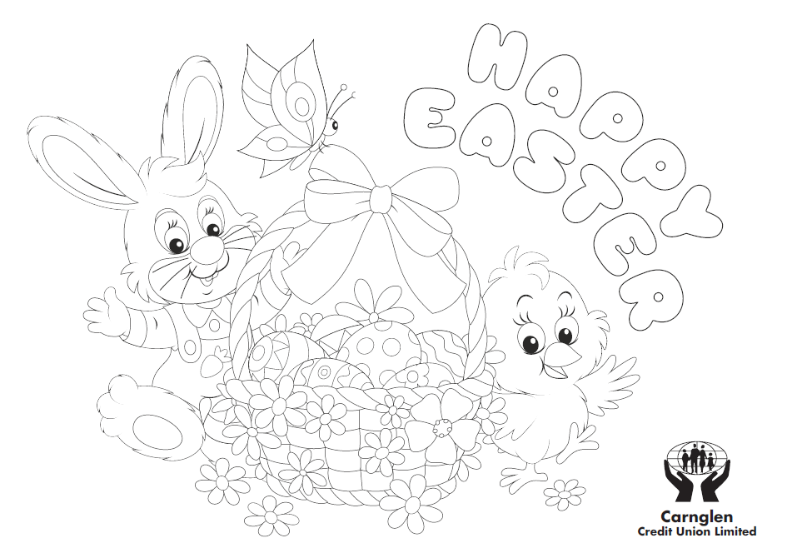
CARNGLEN CREDIT UNION LTD EASTER COMPETITION
Name: __________________________________________________________________________
Age: ___________________________________________________________________________
Address: ________________________________________________________________________
_______________________________________________________________________________
Contact Number: __________________________________________________________________

For your chance to win an Easter Egg please return completed entries to the office before Monday 30th March winners will be announced Wednesday 1st April.

